# 1.Rename file

## Use File class:

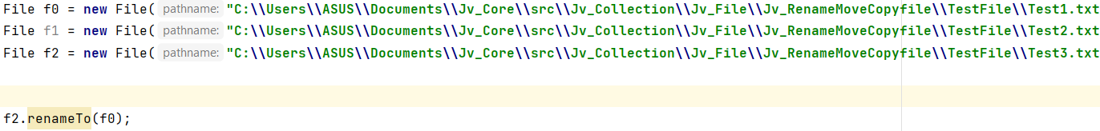

## Use Files class:

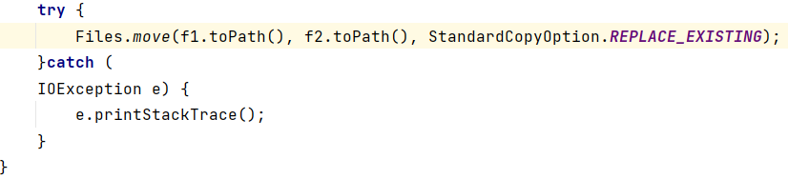

## 2. Move file (Can move sub folder inside):

f1 is original file, f2_new is new file

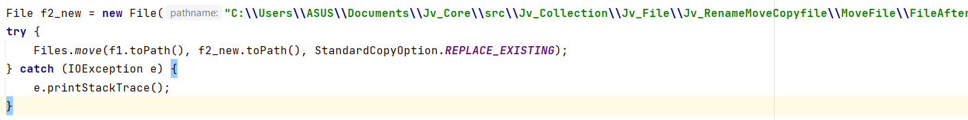

## 3. Delete (can not move sub folder inside original folder to new folder)

### Write a method to copy file and folder inside

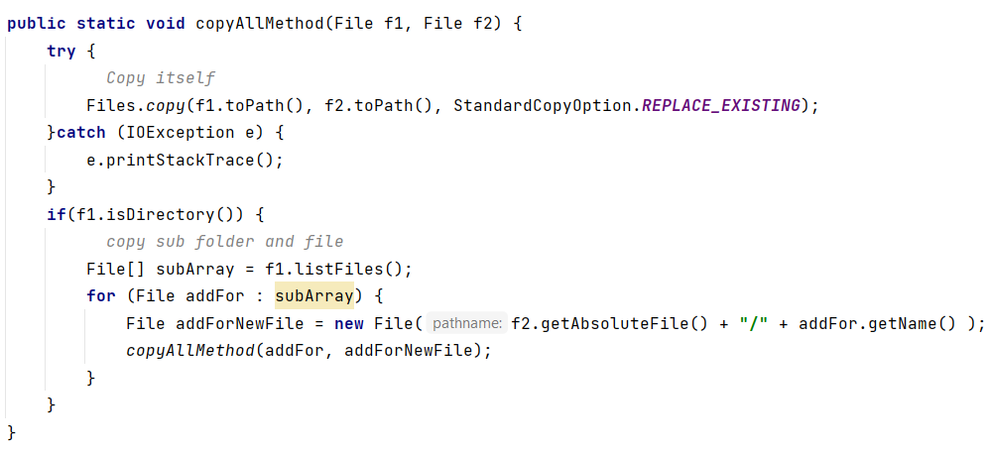

### Run file copy

### 